TCP/IP Referenzmodell(DoD-Referenzmodell)

* DoD Referenzmodell _Department of Defense
* Modell, auf dem die Kommunikation im Internet basiert -> Internet Protokollfamilie
* Praktisch relevant und sehr verbreitet, aber wenig flexibel
* 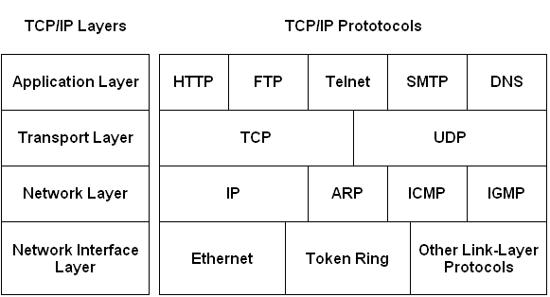This is the topmost layer which indicates the applications and programs that utilize the TCP/IP model for communicating with the user through applications and various tasks performed by the layer, including data representation for the applications executed by the user and forwards it to the transport layer.

The application layer maintains a smooth connection between the application and user for data exchange and offers various features as remote handling of the system, e-mail services, etc. Some of the protocols used in this layer are:

HTTP: Hypertext transfer protocol is used for accessing the information available on the internet.

* This layer is responsible for establishing the connection between the sender and the receiver device and also performs the task of dividing the data from the application layer into packets, which are then used to create sequences.

TCP: Transmission Control Protocol is responsible for the proper transmission of segments over the communication channel. It also establishes a network connection between the source and destination system.

* The Internet layer performs the task of controlling the transmission of the data over the network modes and enacts protocols related to the various steps related to the transmission of data over the channel, which is in the form of packets sent by the previous layer.

IP: This protocol assigns your device with a unique address; the IP address is also responsible for routing the data over the communication channel.

* This layer is the combination of data-link and physical layer, where it is responsible for maintaining the task of sending and receiving data in raw bits, i.e., in binary format over the physical communication modes in the network channel.